- What is HYDRATION?
  - Hydration is the process where Angular attaches its runtime, event listeners, and reactive bindings to server-rendered HTML, reusing the existing DOM instead of recreating it. This is possible because Angular templates are deterministic, declarative, and side-effect free.
- What are SIGNALS?
  - A signal is a reactive value that Angular tracks automatically and re-renders any template or computation that depends on it when it changes.
  - Signal = state + change notification + dependency tracking
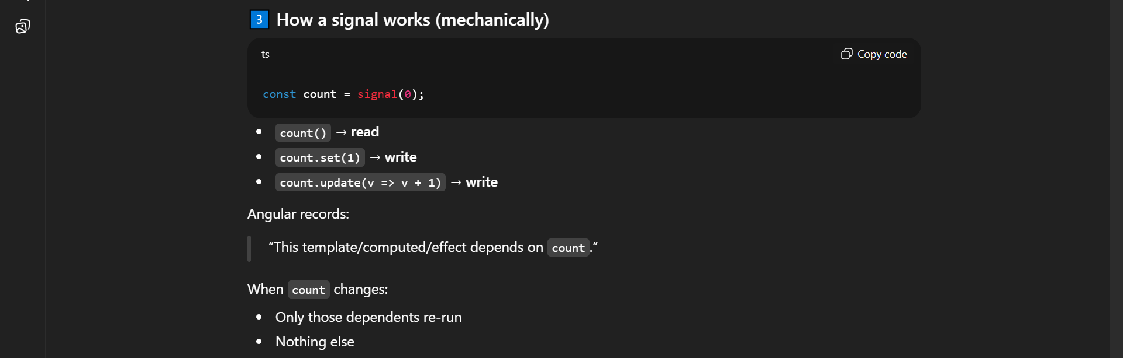
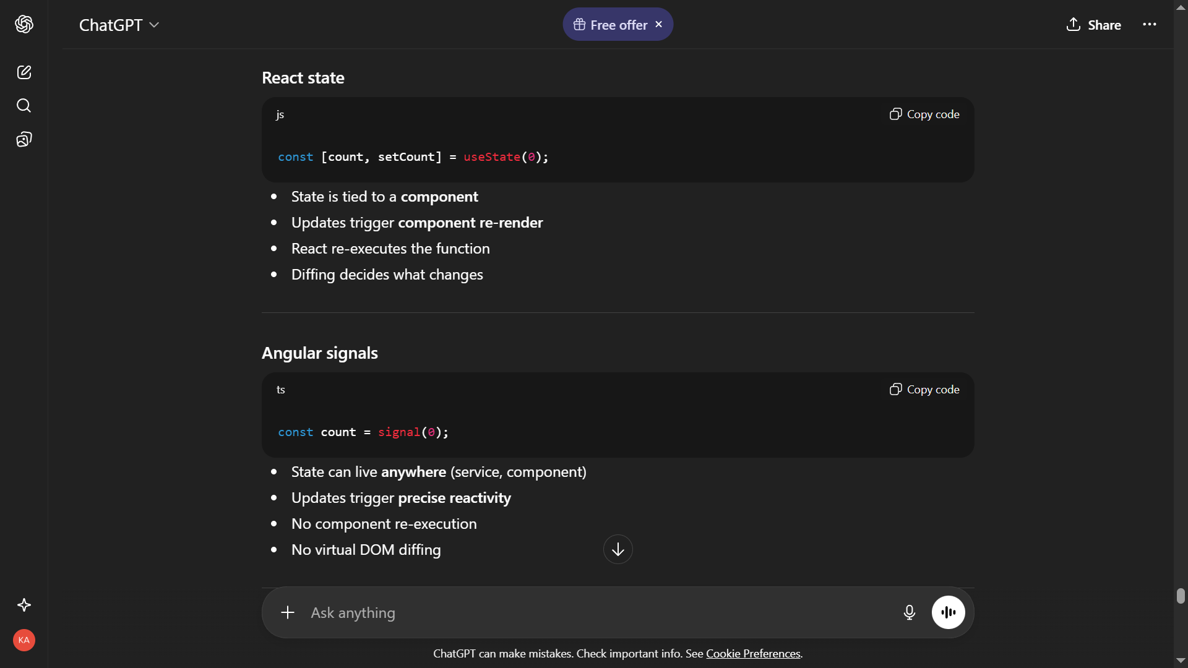

- Important Angular signal rules
  - Services own signals
  - Components consume signals
  - Templates read signals
  - Templates never mutate signals
  - Business logic never in templates
  - React state causes re-renders; Angular signals cause targeted reactive updates.
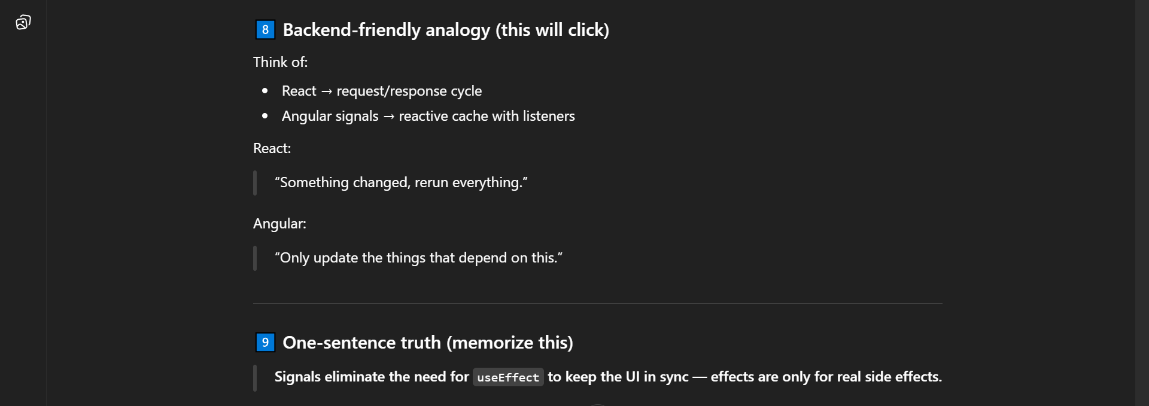
- How changes in DOM happen in Angular?
  - In Angular whenever there is any changes in the signal. Those changes are changed into low-level instructions.
  - For eg: “Update text node #3 with this values”. So Angular executes only those low-level instructions and only changes those nodes due to which the re rendering is minimal on the UI side.

